

**Orient DC Inverter Easy Clean 1 Ton**

**Rs. 54,000/-**

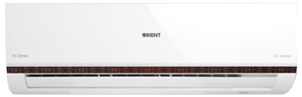

**Product Features**

* High Temperature Stable Running work upto 52C (T3 condition)
* Antifouling and Movable Baffle
* Compact Design
* 3D airflow
* Rounding Natural Air

**Specification**

**Type** Wall Mounted Split AC

**Cooling (Btu/h)** 57000

**Voltage (V)** 220-240

**Power Input (W)** 4800

**EER (Btu/W-h-W/W)** 7.1-4.6